# 1. Scope for var,let and const

## Redeclaration:

Allowed: We can declare a variable with the same name multiple times in the same scope.

Not Allowed: We cannot declare a variable with the same name more than once in the same scope.

## Reassignment:

Allowed: We can change the value of a variable after it has been declared.

Not Allowed: We cannot change the value of a constant after it has been assigned.

* var allows both redeclaration and reassignment.
* let allows reassignment but not redeclaration.
* const allows neither redeclaration nor reassignment.

|  |  |  |  |
| --- | --- | --- | --- |
|  | **Let** | **Var** | **Const** |
| Redeclaration | ❌ | ✅ | ❌ |
| Reassignment | ✅ | ✅ | ❌ |

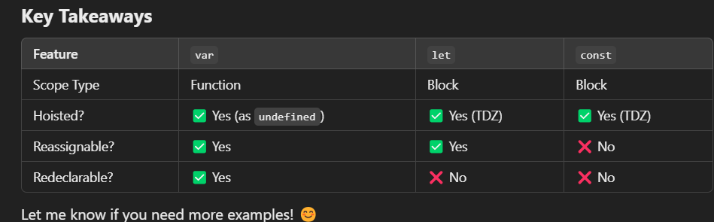

|  |  |
| --- | --- |
|  |  |

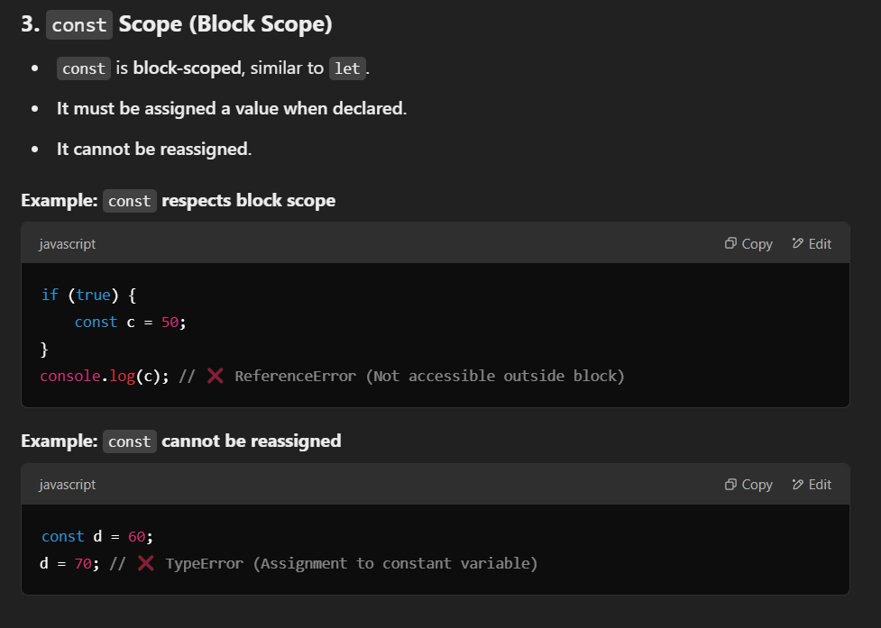

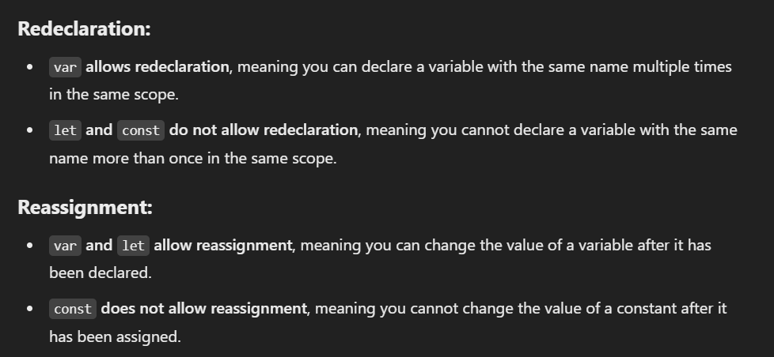

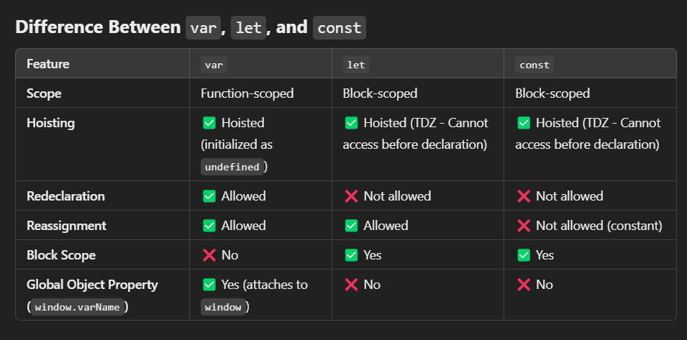

# Hoisting (variable) /temporal dead zone

**1. Hoisting (Variable Hoisting)**

**Definition:** Hoisting is JavaScript's behavior of moving variable and function declarations to the top of their scope before execution.

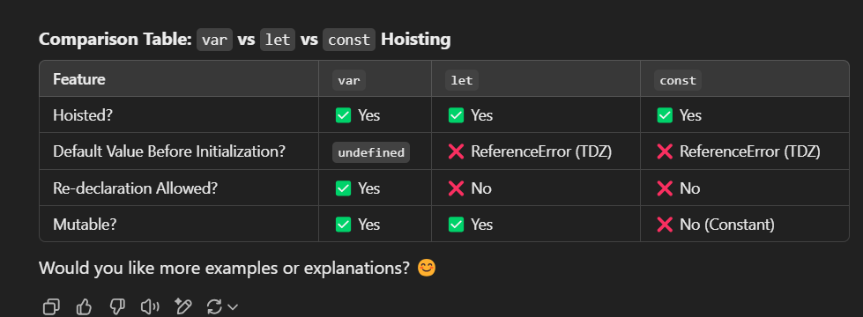

# 3. Execution Context,call stack and Execution stack

